National Careers Week
Thank you for your interest in our National Careers Week events. This event is for Year 12 and 13 students and is on Wednesday 5th of March and Friday 7th of March. It will run to the following timings:
Time | Session
09:45-10:30 | Campus Tour
10:30-12:00 | Subject led activities
12:00-12:30 | Key note speaker (30 mins)
12:30-13:00 | Lunch
13:00-14:30 | Subject led activities
14:30-15:00 | Guest Speaker or Graduate Prospects talk (30 mins)
15:00-15:15 | Summary, close & survey completion

Students will be dropped off at the University of Worcester Arena (WR25JN) and a University of Worcester representative will walk the group to their sessions.
Students will need to bring a packed lunch with them due to the compact nature of the day. The University is a cashless campus, should any student need to buy any additional refreshments.
Please complete the initial booking information and then in the timetables on the subsequent page, how many students you’d like to bring to each session. This form can be returned to schoolsandcolleges@worc.ac.uk

Initial Booking Information
Name of institution: Click or tap here to enter text.
Name of staff member booking: Click or tap here to enter text.
Role of staff member booking: Click or tap here to enter text.
Email address: Click or tap here to enter text.
Minibus/Coach parking required: Click or tap here to enter text.
Total number of Year 12 students attending: Click or tap here to enter text.
Total number of Year 13 students attending: Click or tap here to enter text.
Total number of staff attending: Click or tap here to enter text.

Wednesday 5th March
Please note sessions take place across different buildings that are close to each other a map is below and further information can be found about the locations by clicking CTRL and on the map. 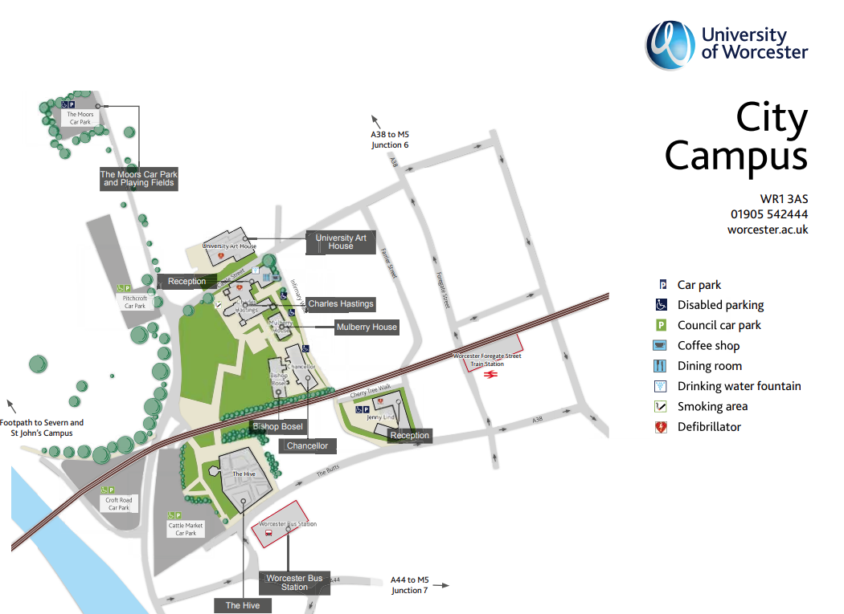
Course Area (am) | No. of students | Course Area (pm) | No. of students
Business & Computing | Enter here | Journalism* | Enter here
Policing | Enter here | Law | Enter here
Psychology | Enter here | Criminology | Enter here
Dance & Performance* | Enter here | Theatre & Performance* | Enter here
Graphic Design | Enter here | Animation | Enter here
Screen Writing & Film Making | Enter here
Illustration | Enter here
*Session takes place at St John’s Campus. See map below.

Friday 7th March
Please note sessions take place across different campuses that are close to each other a map is below and further information can be found about the locations by clicking CTRL and on the map.
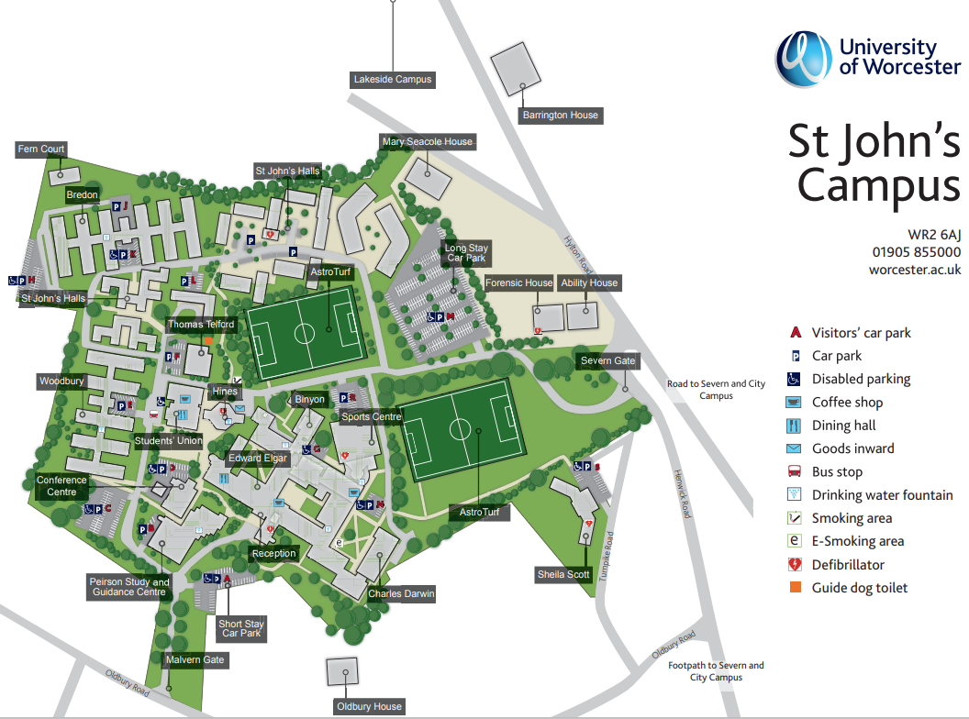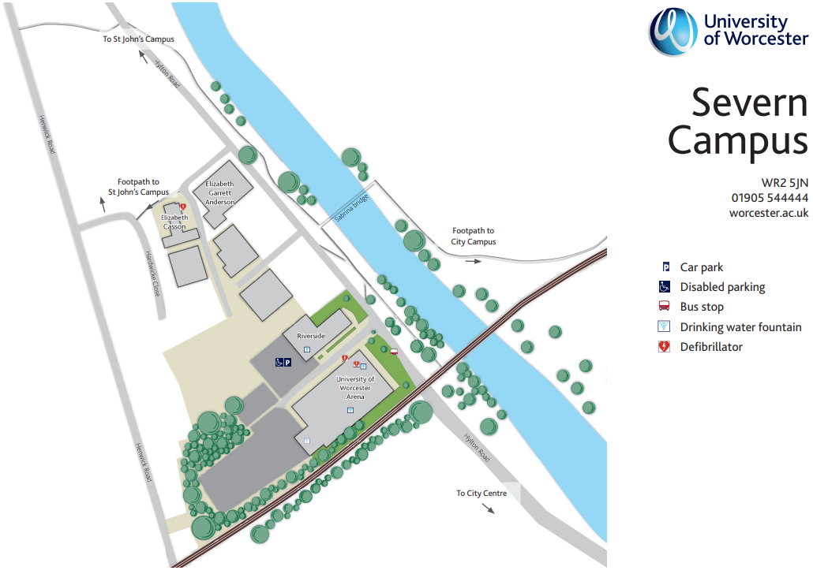
Course Area (am) | No. of students | Course Area (pm) | No. of students
Occupational Therapy | Enter here
Social Work | Enter here | Nursing | Enter here
Geography | Enter here | Environmental Management | Enter here
Sport and Exercise Science (part 1) | Enter here | Sport and Exercise Science (part 2) | Enter here
Sports Coaching (part 1) | Enter here | Sports Coaching (part 2) | Enter here
Sports Therapy (part 1) | Enter here | Sports Therapy (part 2) | Enter here
Sports Business (part 1) | Enter here | Sports Business (part 2) | Enter here
Education (part 1) | Enter here | Education (part 2) | Enter here

